**Software Testing**

**Assignment#1**

**Nada Mohamed Fathy Omar** [20186031](mailto:s.makady@fci-cu.edu.eg)

**Ayat Hany Ahmed**  20186007

**Task#1**

1. **Explain what is wrong with the given code. Describe the fault precisely by proposing a modification to the code.**

**Answer:**

* The wrong with the code is the condition of the for loop

->(i>0);

* This means that the for loop will not go to the first element of the array and this is the fault line in the code.
* And to correct it we need to put (=) in the condition and this will be like that -> (i>=0); with this condition of the for loop will go to the first element of the array.
* As in the test case that was given x =[2,3,5], y w= 2 , and the expected output was 0 but the actual output was -1 and this is wrong output.

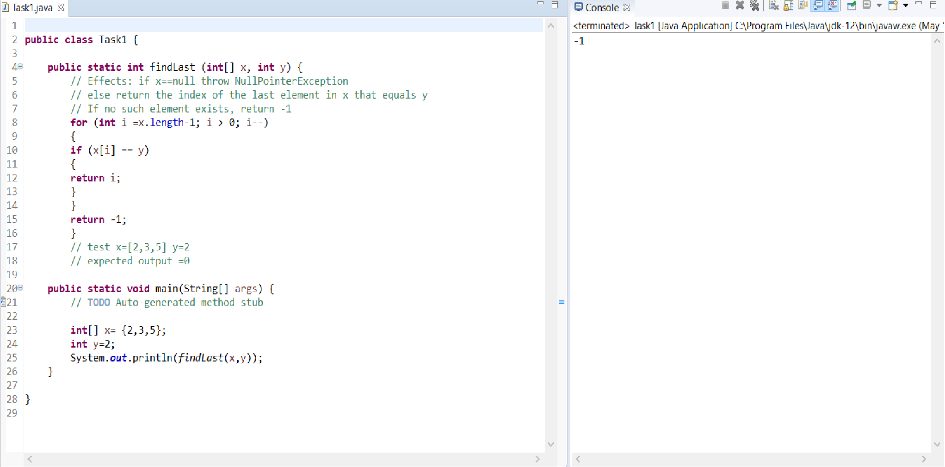

1. **If possible, give a test case that does not execute the fault. If not, briefly explain why not.**

**Answer:**

* There is no test case like that because every time we will enter this function with any input so the for loop will execute its condition on this input, the fault line here is the condition.

1. **If possible, give a test case that executes the fault, but does not result in an error state. If not, briefly explain why not.**

**Answer:**

* There is no test case like that because every time we will enter this function with any input so the for loop will execute its condition on this input, the fault line here is the condition, and this will cause an error state.

1. **If possible give a test case that results in an error, but not a failure. If not, briefly explain why not. Hint: Don’t forget about the program counter.**

**Answer:**

* The test case will be x = [3,2,5] , y = 2 , the expected output for this test case will be 1(the index of the element that wants).

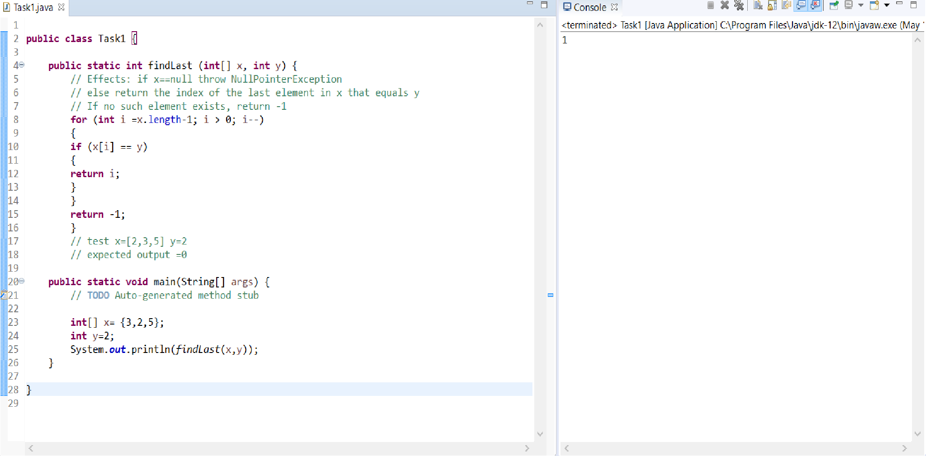

* We have another test case , this will be x=[2,3,5] , y=3 **,**

the expected output for this test case will be 1(the index of the element that wants).

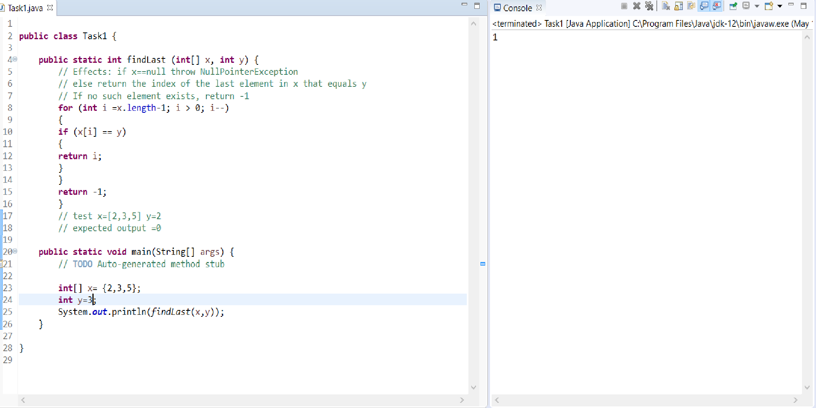

* We have another test case , this will be x=[2,3,5] , y=5 **,**

the expected output for this test case will be 2(the index of the element that wants).

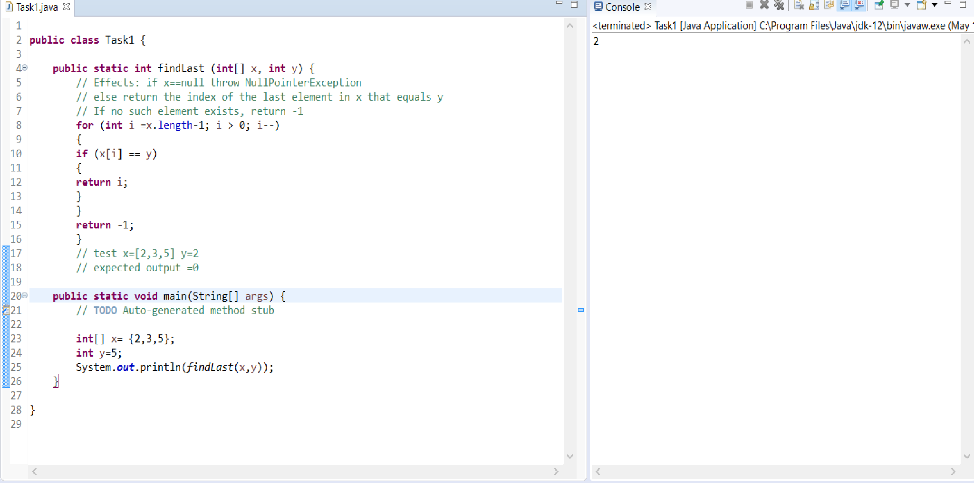

* The program counter:

|  |  |  |  |
| --- | --- | --- | --- |
| Line number | i | First checked element array | array |
| 1 | 2 |  | [2,3,5] |
| 2 | 2 | (x[2]=5==2)False | [2,3,5] |
| 1 | 1 |  | [2,3,5] |
| 2 | 1 | (x[1]=3==2)False | [2,3,5] |
| 1 | 0 |  | [2,3,5] |
| 4 |  | Return -1 | [2,3,5] |

1. **For the given test case, describe the first error state. Be sure to describe the complete state.**

**Answer:**

* The first error state is the for loop does not go to the first element with the index zero, the y was equals for 2 , and the expected output was 0 but the actual output was -1 and this is wrong output.
* The complete state is: x = [2, 3, 5], fault executed, error, failure.

